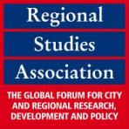
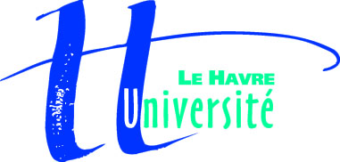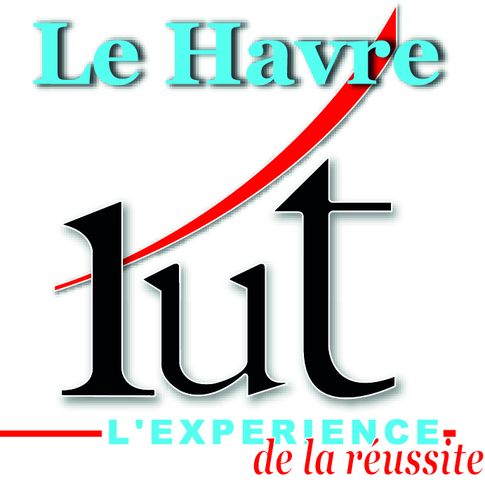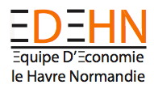

Call for Papers
Workshop on
“Cities regeneration processes: the role of entrepreneurs, residents and tourists”
Sept. 19 & 20, 2013
University of Le Havre (France)
deadline for submitting papers to the international workshop : June 30, 2013
Many metropolitan cities have been going through a process of regeneration to make themselves attractive destinations for increasingly mobile businesses to locate. The regeneration process has also focused on attracting new residents, tourists, conferences and events. The implication is that by attracting income either from business relocation or resident/visitor expenditure this will create additional expenditure leading to increased economic growth within the metropolitan area.
Whilst there have been many differing approaches to achieve these goals a commonality appears to be that they have been ‘managed’ by a network of private and public institutions. Recent literature has described this phenomenon as ‘Entrepreneurial Urban Growth.’ Two recent examples of metropolitan cities which have embarked on this journey are Le Havre in France and Glasgow in Scotland. This two day conference/workshop co-organized by Glasgow Caledonian University (GCU) and Le Havre University and sponsored by the Regional Studies Association, will explore the issues raised by these types of regeneration processes. Among them are the development and implementation of regeneration strategies ranging from cluster-oriented to cultural-oriented, the role of geographical and institutional proximities in enterprise development, partnerships between public and private for attracting entrepreneurial activity in the reconversion of former industrial areas in city centers, the finance and governance of regeneration processes in times of recession time, and so on. The workshop will therefore be of interest to researchers and policy makers alike, particularly in the fields of:
Urban geography, Enterprise development, Territorial governance, Networks, Local Public Finance, Tourism, Events Management, …
We encourage economists, geographers, planners, business scholar researchers as well as policy and entrepreneurial experts to submit their research and attend the workshops. English will be the working language.
Please submit to Pascal RICORDEL (pascal.ricordel@univ-lehavre.fr) a short abstract (200 words) plus either a copy of the final paper or 2-page detailed summary before June 30, 2013.
Organizing Committee: Jean-Marie BASSOUAMINA (EDEHN, Caisse des Dépôts et Consignation), Etienne FARVAQUE (EDHEN, Le Havre University), Arnaud LEMARCHAND (EDEHN, Le Havre University), Pascal RICORDEL (EDEHN, Le Havre University), Geoff WHITTAM (Glasgow Caledonian University)
Contact: Pascal RICORDEL (pascal.ricordel@univ-lehavre.fr)
Scientific Committee: Andy CUMBERS (Glasgow University), Mike DANSON (Heriot-Watt University), Etienne FARVAQUE (EDHEN, Le Havre University), Hugues JENNEQUIN (CREAM, Rouen University), Arnaud LEMARCHAND (EDEHN, Le Havre University), Jean-Jacques NOWAK (Lille University), Pascal RICORDEL (Le Havre University), Geoff WHITTAM (Glasgow Caledonian University),

Important informations:
When: Sept 19, 3013 – Sept 20, 2013
Where: University of Le Havre (France)
New Submission Deadline: (June 30, 3013)
Submission address: pascal.ricordel@univ-lehavre.fr
Notification Due: 12 Jul, 2013
Final version due: Sept 1, 2013

